**Assignment -1**

Connect and disconnect with login Access

* What happens when you login a non-existent users or username?
  + Provide Screenshot and What you understand, explain in short brief?
* ***When you login with a non-existent user we are not able to login to centos machine***

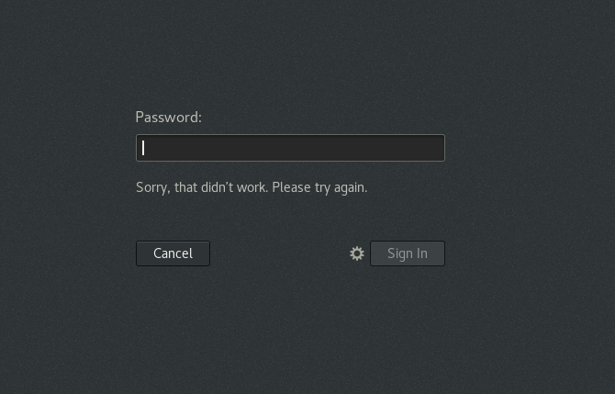

**Assignment -2**

Password changing

* Login into your account and then change password?
  + Change your password into ***IneuR0n#42*** and hit the **Enter** key
    - Explain what happen and give screenshot?

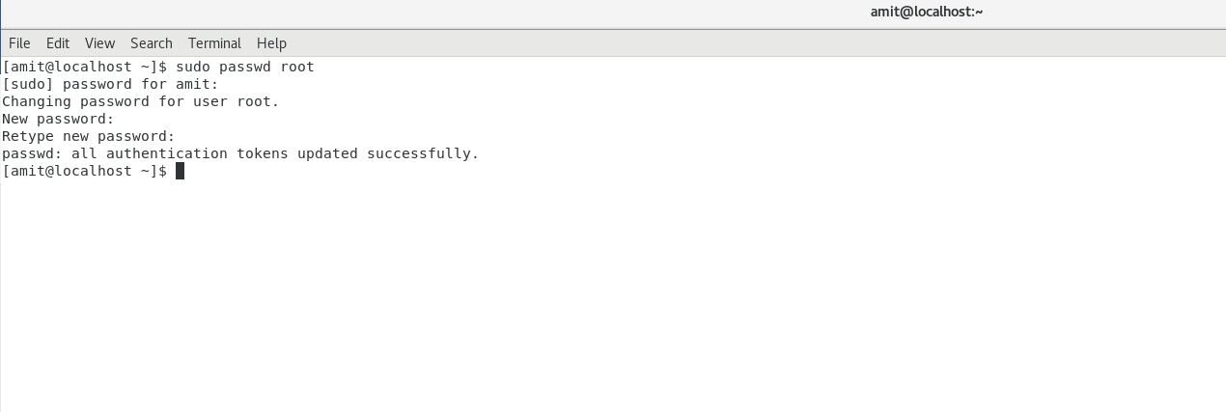

* + Try again to change password but use like password ***1234*** or ***abcd***
    - Explain what happen and give screenshot?

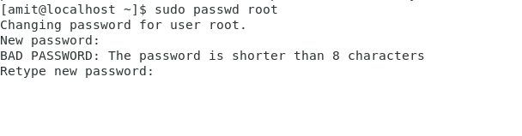

* + Try again to change password but now don’t use any password just hit **Enter** key
    - Explain what happen and give screenshot?

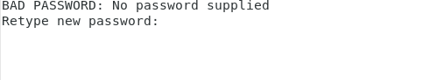

**Assignment -3**

Working with Directories

* Enter the command **cd /** and then **ls** and then hit **Enter** key
* Take screenshot and explain what output we got?

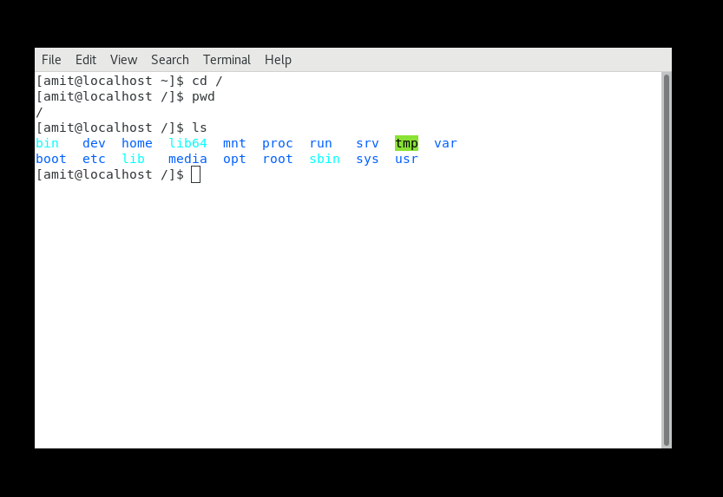

* Enter the command now **cd /home** and then hit **Enter** key
* Do **ls,** provide screenshot and explain what is **/home** directory used for?

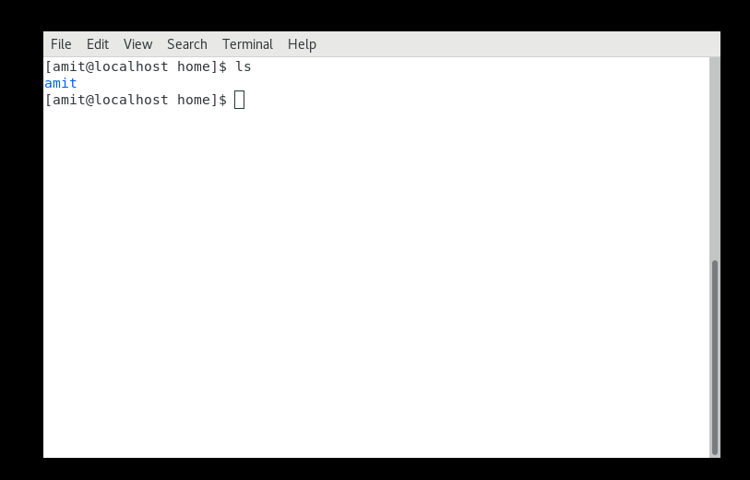

* Enter **cd ..** and hit **Enter** key [ *Note: here we have space after cd then use double dot*]
* Check what happen and give screenshot?
* ***Can see system related folders like tmp, var etc***

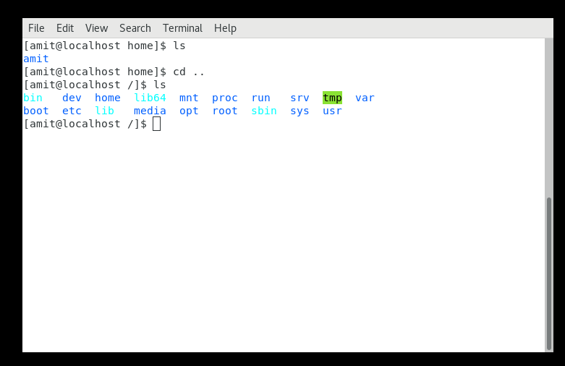

* Now enter **cd /var/www/html** and then type **cd** and hit **Enter** key
* Explain what happen and give screenshot?

**It went to user directory**

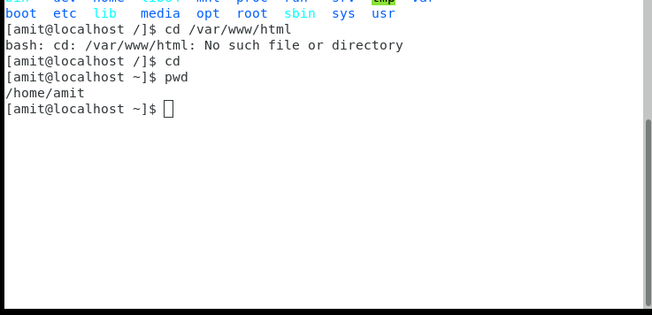

* Now type **cd /root** and then hit **Enter** key
* Do **ls,** check any output we have on screen if yes then take screenshot?

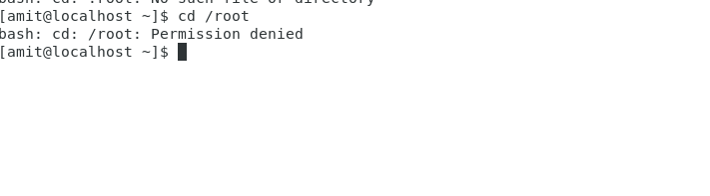

**Assignment-4**

Working with File Listing

* Go to **cd /etc** and type **ls**
  + Take screenshot and explain what files you have seeing?
  + Take screenshot and explain what different output you found compare to previous command you used?
* ***After doing ls we see configuration files and folders***

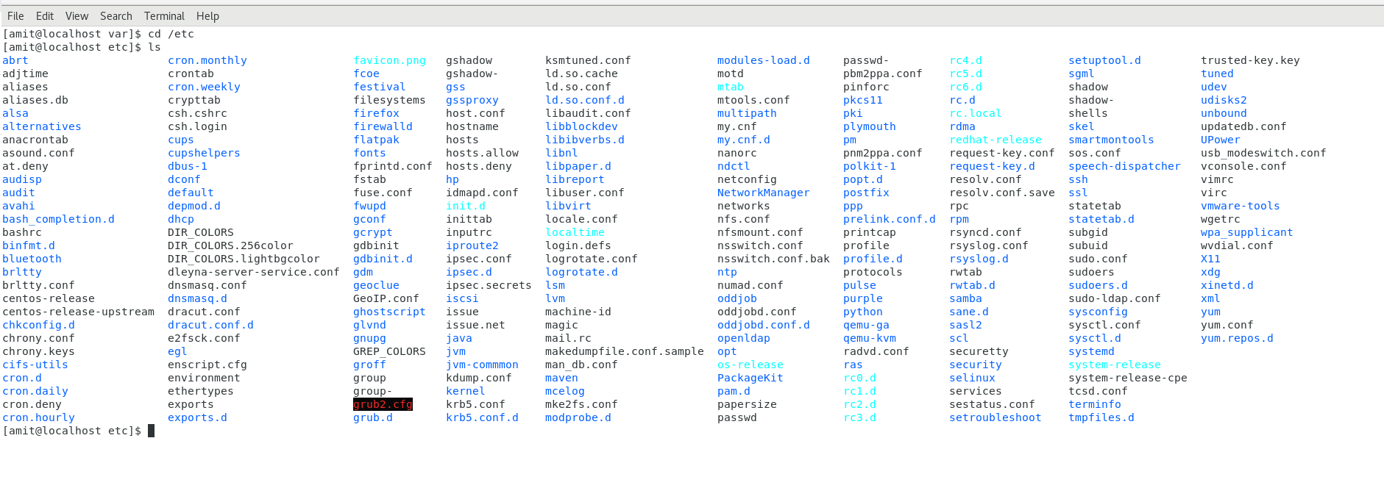

* Then type **ls -al** and hit **Enter** key
* Take screenshot and explain what new file or directory you found?
* ***It lists al the files in the given directories***

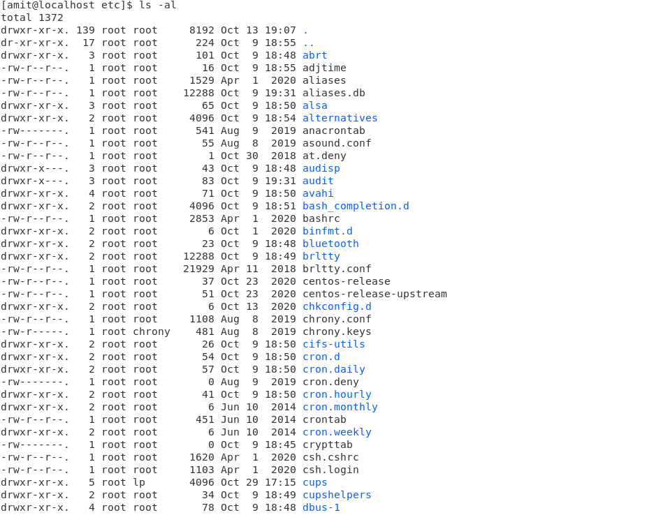

* Then use **ls -i** and hit **Enter** key
* Now see what different output its shows and take screenshot?

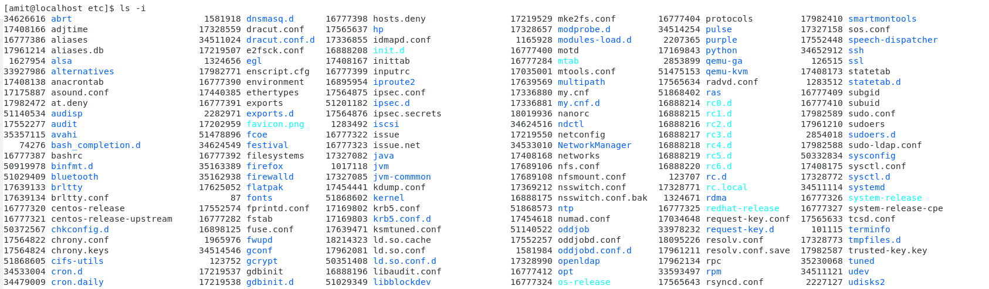

**Assignment-5**

Know where you are and where you working

*Here we use* ***pwd, cd and ls*** *as combine task to understand where you working on terminal and how you can switch from one directory to another one.*

* Open terminal after restart the linux
  + Check which location you working, type **pwd** and take screenshot
* Now use **cd /var** and hit **Enter** key
  + Do **ls,** and see what output comes, give screenshot?
* Do explore other help options of each command to learn more other things we can do with these commands

